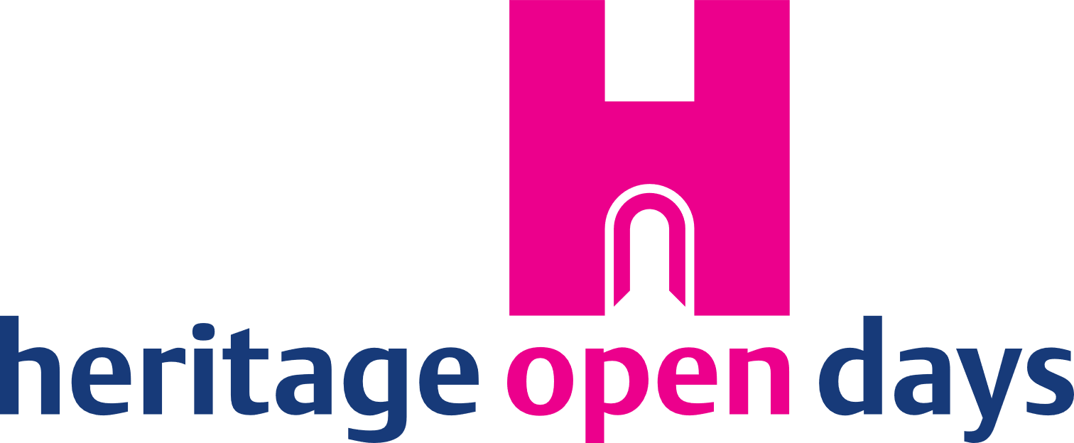
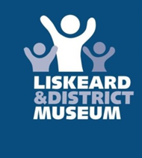

Lego and Meccano Machine Invention Competition

Personal Details

Name of entrant
If under 18 name of parent / guardian
(please also use their details below)
Address
Telephone Number
Email address

Categories (please tick which category you are entering in)

Up to 10 | 10-17
18+

Your invention
Dimensions in cm
(50cm in any direction)
A short description on what your invention does (75 words max)

Closing date for entries is 4pm 31st August 2022.
Please email this form to contact@liskeardmuseum.co.uk or deliver to Liskeard Tourist Information Centre, Foresters Hall, Pike Street, Liskeard PL14 3JE.
Shortlisted entries will be informed by September 7th on their success and asked to bring their machine to the museum by September 9th to be put on display at the museum for the Heritage Open Days. This will allow visitors to vote on their favourite machines for two weeks. The machine with the most votes will win a prize.

Rules
The machines must be of your own invention, and not created using a kit or set instructions by Lego or Meccano. It can be no larger than 50cm in any direction.
There has to be a description of what your machine does, which if shortlisted, will be on display alongside your creation at the museum.

Photo / video consent

Please complete the form below to give us permission to take photos of you / your child and your artwork to use in our printed and online publicity.
I give Liskeard & District Museum permission to take photographs and / or video of me / my child and my artwork.
I grant Liskeard & District Museum full rights to use the images resulting from the photography/video filming, and any reproductions or adaptations of the images for publicity or other purposes to help achieve the group’s aims.
This might include (but is not limited to), the right to use them in their printed and online publicity, social media, press releases and funding applications.
Name of entrant

Name of parent / guardian (if under 18)

Signature (or signature of parent / guardian)

Date

The museum will make every reasonable effort to ensure that name credits are given to any photograph published in any medium.
The museum takes no responsibility for damage sustained to the creation while it is in our possession.

